A PROJECT REPORT

ON

AMD SemiConductors

*Submitted*

*By*

C V Sreyas DeviPrasad

(En.NO - 03051700083)

*In fulfilment for the award of the degree*

*Of*

Bachelor of Computer Application

*In*

Computer Department

V.J. Modha Collage Porbandar

October 2019



Acknowledgement

The successful and final outcome of this Project required lots of guidance and assistance from many people and I am extremely fortunate to have completed my Project work. Whatever I have done is only due to such guidance and assistance and I should not forget to thank them. I respect and thank **Mr.** **Thakrar Zalak** at first place for giving me an opportunity to do this Project and providing me support and guidance through which I could complete the Project in time. I am extremely grateful to him for providing such co-operation.

This Project also could not be completed without the help of my parents. I would also like to thank my friends for their most valuable effort to help me. Last but not the least; I would once again like to express my gratitude to my friends, teachers, my parents for their support and willingness to spend their important time with me.

It is our great pleasure to represent our project as one Desktop application titled “**AMD SemiConductors**” and which we conceived in the 5th semester of BCA affiliated with BKNMU (Bhakt Kavi Narshinh Mehta University).

We are also thankful to the BKNMU (Bhakt Kavi Narshinh Mehta University) for including this project development subject in our syllabus. We got a golden opportunity to test and implement our creativity and programming skill simultaneously. Lastly, we would like to extend our sincere thanks to our advisors, classmates as well as all the books and websites.

**Index**

|  |  |  |
| --- | --- | --- |
| **Sr NO** | **Topic Name** | **Page No** |
| Chapter-1 | **INTRODUCTION**  1.1 Purpose  1.2 Scope  1.3 Technology & Literature Review | 5 |
| Chapter-2 | **SYSTEM ANALYSIS**  2.1Problem Definition  2.2Process Model  2.3Requirement Analysis  2.4SRS  2.5Grant Chart | 12 |
| Chapter-3 | **SYSTEM DESIGN**  3.1 Data Flow Diagram  3.2 E-R Diagram  3.3 Use Case Diagram | 23 |
| Chapter-4 | **DATA DICTIONARY**  4.1 Data Dictionary | 29 |
| Chapter-5 | **INPUT AND OUTPUT DESIGN**  5.1 Admin Layout  5.2 Client Layout | 35 |
| Chapter-6 | **LIMITATIONS AND FUTURE ENHANCEMENT**  6.1 Limitations  6.2 Further Enhancement | 51 |
| Chapter-7 | **CONCLUSION**  7.1 Conclusion  7.2 Advantages | 53 |
| Chapter-8 | **BIBLIOGRAPHY** | 55 |
| Chapter-9 | **REFERENCES** | 57 |

**Abstract:**

**Project Type:** Website

**Project Title:** AMD Semiconductors

**Shop Name:** Advanced Micro Devices

**Project Language:** PHP accompanied by HTML and CSS

**Database:** MySQL

**Description:**

This is a website for the company named Advanced Micro Devices, commonly known as AMD or the ‘Red Team’. Recently AMD launched their Ryzen 3000 Series Processors and the new Radeon 5000 series GPUs. This website will have the Products listed.

An Admin Panel, Feedback form, Product Listing, etc have been included in this website.

**Advantages:**

* Listing of all the CPUs and GPUs
* Admin Panel to manage the Products and News
* Links to buy the Products

Chapter No: 1

Introduction

1.1 Purpose

1.2 Scope

1.3 Technology and Literature Review

* 1. Purpose of the Website

The main purpose of this website is to list out the products to the masses via internet. This will help the company to attract potential customers. This website can also be used as an advertising platform. This website will give an opportunity to the company to present their products to the masses and potentially increase the sales of the company.

In this website the company can list out their products and list its specifications. This would help any potential customers to read and determine what to buy and what not to buy.

By covering new launches and listing them on the website, people can sit at their home and have a look at the products of the company and make a decision to buy it or not. Listing out the specs of the products will help the customers/users/reviewers to compare the products with the competitors and agree on which one is better than the others.

* 1. Scope

This website may help to increase the awareness of the company and its products. This will in turn help the company to increase their sales. With the help of this website, the company can determine what users/clients like based on the traffic and page visits.

**Goals of the system:**

* **List out the products**
* **Advertise the products**
* **List out the features of the products**
* **Showcase the new products**
* **A way to communicate with the masses**
* **Easy access to the information**
  1. Technology & Literature Review

**Front End:**

* **HTML:**

Hypertext Markup Language (HTML) is the standard markup language for documents designed to be displayed in a web browser. It can be assisted by technologies such as Cascading Style Sheets (CSS) and scripting languages such as JavaScript.

Web browsers receive HTML documents from a web server or from local storage and render the documents into multimedia web pages. HTML describes the structure of a web page semantically and originally included cues for the appearance of the document.

HTML can embed programs written in a scripting language such as JavaScript, which affects the behavior and content of web pages. Inclusion of CSS defines the look and layout of content. The World Wide Web Consortium (W3C), former maintainer of the HTML and current maintainer of the CSS standards, has encouraged the use of CSS over explicit presentational HTML since 1997.

* **CSS:**

Cascading Style Sheets (CSS) is a style sheet language used for describing the presentation of a document written in a markup language like HTML. CSS is a cornerstone technology of the World Wide Web, alongside HTML and JavaScript.

CSS is designed to enable the separation of presentation and content, including layout, colors, and fonts. This separation can improve content accessibility, provide more flexibility and control in the specification of presentation characteristics, enable multiple web pages to share formatting by specifying the relevant CSS in a separate .css file, and reduce complexity and repetition in the structural content.

* **JavaScript:**

JavaScript, often abbreviated as JS, is a [high level](https://en.wikipedia.org/wiki/High-level_programming_language), [interpreted](https://en.wikipedia.org/wiki/Interpreted_language) [scripting language](https://en.wikipedia.org/wiki/Scripting_language) that conforms to the [ECMAScript](https://en.wikipedia.org/wiki/ECMAScript) specification. JavaScript has [curly-bracket syntax](https://en.wikipedia.org/wiki/List_of_programming_languages_by_type#Curly-bracket_languages), [dynamic typing](https://en.wikipedia.org/wiki/Dynamic_typing), [prototype-based](https://en.wikipedia.org/wiki/Prototype-based_programming) [object-orientation](https://en.wikipedia.org/wiki/Object-oriented_programming), and [first-class functions](https://en.wikipedia.org/wiki/First-class_function).

Alongside [HTML](https://en.wikipedia.org/wiki/HTML) and [CSS](https://en.wikipedia.org/wiki/CSS), JavaScript is one of the core technologies of the [World Wide Web](https://en.wikipedia.org/wiki/World_Wide_Web). JavaScript enables interactive [web pages](https://en.wikipedia.org/wiki/Web_page) and is an essential part of [web applications](https://en.wikipedia.org/wiki/Web_application). The vast majority of [websites](https://en.wikipedia.org/wiki/Website) use it, and major [web browsers](https://en.wikipedia.org/wiki/Web_browser) have a dedicated [JavaScript engine](https://en.wikipedia.org/wiki/JavaScript_engine) to execute it.

As a multi-paradigm language, JavaScript supports [event-driven](https://en.wikipedia.org/wiki/Event-driven_programming), [functional](https://en.wikipedia.org/wiki/Functional_programming), and [imperative](https://en.wikipedia.org/wiki/Imperative_programming) (including [object-oriented](https://en.wikipedia.org/wiki/Object-oriented_programming) and [prototype-based](https://en.wikipedia.org/wiki/Prototype-based_programming)) [programming styles](https://en.wikipedia.org/wiki/Programming_paradigm). It has [APIs](https://en.wikipedia.org/wiki/Application_programming_interface) for working with text, [arrays](https://en.wikipedia.org/wiki/Array_data_type), dates, [regular expressions](https://en.wikipedia.org/wiki/Regular_expression), and the [DOM](https://en.wikipedia.org/wiki/Document_Object_Model), but the language itself does not include any [I/O](https://en.wikipedia.org/wiki/Input/output), such as [networking](https://en.wikipedia.org/wiki/Computer_network), [storage](https://en.wikipedia.org/wiki/Data_storage), or [graphics](https://en.wikipedia.org/wiki/Computer_graphics) facilities. It relies upon the host environment in which it is embedded to provide these features.

Initially only implemented [client-side](https://en.wikipedia.org/wiki/Client-side) in web browsers, JavaScript engines are now embedded in many other types of host software, including [server-side](https://en.wikipedia.org/wiki/Server-side) in web servers and databases, and in non-web programs such as word processors and [PDF](https://en.wikipedia.org/wiki/Portable_Document_Format) software, and in runtime environments that make JavaScript available for writing mobile and desktop applications, including desktop widgets.

* **jQuery:**

jQuery is a JavaScript library designed to simplify HTML DOM tree traversal and manipulation, as well as event handling, CSS animation, and Ajax. It is free, open-source software using the permissive MIT License. As of May 2019, jQuery is used by 73% of the 10 million most popular websites. Web analysis indicates that it is the most widely deployed JavaScript library by a large margin, having 3 to 4 times more usage than any other JavaScript library.

jQuery's syntax is designed to make it easier to navigate a document, select DOM elements, create animations, handle events, and develop Ajax applications. jQuery also provides capabilities for developers to create plug-ins on top of the JavaScript library. This enables developers to create abstractions for low-level interaction and animation, advanced effects and high-level, themeable widgets. The modular approach to the jQuery library allows the creation of powerful dynamic web pages and Web applications.

**Back End:**

* **PHP:**

PHP: Hypertext Preprocessor (or simply PHP) is a general-purpose programming language originally designed for web development. It was originally created by Rasmus Lerdorf in 1994. The PHP reference implementation is now produced by The PHP Group. PHP originally stood for Personal Home Page, but it now stands for the recursive initialism PHP: Hypertext Preprocessor.

PHP code may be executed with a command line interface (CLI), embedded into HTML code, or used in combination with various web template systems, web content management systems, and web frameworks. PHP code is usually processed by a PHP interpreter implemented as a module in a web server or as a Common Gateway Interface (CGI) executable. The web server outputs the results of the interpreted and executed PHP code, which may be any type of data, such as generated HTML code or binary image data. PHP can be used for many programming tasks outside of the web context, such as standalone graphical applications and robotic drone control.

* **MySQL:**

MySQL is an open-source relational database management system (RDBMS). Its name is a combination of "My", the name of co-founder Michael Widenius's daughter, and "SQL", the abbreviation for Structured Query Language.

MySQL is free and open-source software under the terms of the GNU General Public License, and is also available under a variety of proprietary licenses. MySQL was owned and sponsored by the Swedish company MySQL AB, which was bought by Sun Microsystems (now Oracle Corporation). In 2010, when Oracle acquired Sun, Widenius forked the open-source MySQL project to create MariaDB.

MySQL is a component of the LAMP web application software stack (and others), which is an acronym for Linux, Apache, MySQL, Perl/PHP/Python. MySQL is used by many database-driven web applications, including Drupal, Joomla, phpBB, and WordPress. MySQL is also used by many popular websites, including Facebook, Flickr, MediaWiki, Twitter, and YouTube.

Chapter No : 2

system analysis

2.1 Problem Definition

2.2 Process Model

2.3 Requirement analysis

2.4 SRS

* 1. Grant Chart
  2. Problem Definition

To increase the sales and awareness about the product of the company, in the masses, having a website is kind of mandatory. Having a website means that the people can look up your products online on your website and determine whether they need it or not. Any company that is related to the computing industry, should have their own attractive website.

* 1. Process Model

Iterative Waterfall Model

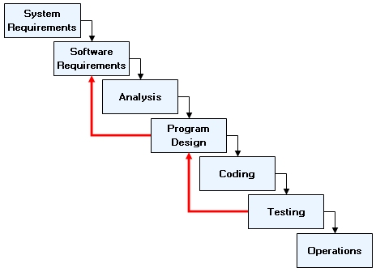

* Advantages of Iterative Waterfall Model

1. Simple and Easy to Understand
2. Each Phase has well defined input and output
3. It works well for small project where requirements are clear and well understood
4. It divides complex tasks into more manageable small tasks

* Application of Iterative Waterfall Model

1. When requirements are clear and fixed
2. Product Definition is Stable & Technology is understood
3. When project is short

* Why Iterative Waterfall Model??

The Incremental Model is an evolution of the waterfall model, where the waterfall model incrementally applied. The Incremental Process Model combines elements of the linear sequential model (applied repetitively) with the iterative philosophy of prototyping.

* 1. Requirement Analysis

**Hardware Requirements**

* Operating System : 32 bit / 64 bit
* RAM : 512 MB or More
* Processor : any x86 CPU

**Software Requirements**

* Front End Tool : Notepad++, Visual Studio Code, Chrome, Edge, Mozilla FireFox
* Back End Tool : PhpMyAdmin
* Development Tool : Notepad++, Visual Studio Code, XAMPP Server
* Supported Operating Systems: Any OS that can run Browsers like Mozilla Firefox, Edge, Chrome
  1. System Requirement Specification

REQUIREMENT SPECIFICATION OF USER 1: ADMIN

R1: Login

R2: Manage CPU

R3: Manage GPU

R4: Manage News

R5: Manage Feedback

R6: Manage Users

REQUIREMENT SPECIFICATION OF USER 2: Client

R1: Login

R2: Register

R3: Give Feedback

R4: View CPU

R5: View GPU

R6: View News

SYSTEM REQUIREMENT SPECIFICATION FOR ADMIN

**R1: Login**

Description: This page will authenticate the admin user.

State: The beginning page for the admin panel. Here the Username and Password is requested.

Input: Username and Password are the Input.

Output: The result of authentication process.

Process: The user’s input will be matched in the database and then admin field will be checked to see if the user is admin or not.

**R2: Manage CPU**

Description: Using these pages, the admin can manage the CPUs listed in the website.

State: Is the admin is logged in, then the admin can insert or update or delete a CPU.

Input: Insert or Delete or Update of the CPU

Output: The modified records.

Process: Depending on the selection of the user, the records will be altered or

inserted.

**R3: Manage GPU**

Description: Using these pages, the admin can manage the GPUs listed in the website.

State: Is the admin is logged in, then the admin can insert or update or delete a GPU.

Input: Insert or Delete or Update of the GPU

Output: The modified records.

Process: Depending on the selection of the user, the records will be altered or inserted.

**R4: Manage News**

Description: Using these pages, the admin can manage the News listed in the website.

State: Is the admin is logged in, then the admin can insert or update or delete a News.

Input: Insert or Delete or Update of the News

Output: The modified records.

Process: Depending on the selection of the user, the records will be altered or inserted.

**R5: Manage Feedback**

Description: Using this page, the admin can manage the Feedbacks given by the registered users.

State: Is the admin is logged in, then the admin can view and delete the feedbacks.

Input: Delete a Feedback record

Output: The modified records.

Process: Depending on the selection of the user, the records will be deleted.

**R6: Manage Users**

Description: Using this page, the admin can manage the Users.

State: Is the admin is logged in, then the admin can view and delete.

Input: Delete a User or make it admin

Output: The modified records.

Process: Depending on the selection of the user, the records will be altered or deleted.

SYSTEM REQUIREMENT SPECIFICATION FOR CLIENT

**R1: Login**

Description: This page will authenticate the user.

State: This page is used when someone wants to give feedbacks. Here the Username and Password is requested.

Input: Username and Password are the Input.

Output: The result of authentication process.

Process: The user’s input will be matched in the database to authenticate the user.

**R2: Register**

Description: This page will register a new user.

State: This page contains various fields for a user to fill up to register themselves with the website.

Input: First Name, Last Name, Username, Password, Confirm Password, Mobile Number, E-mail and Date of Birth.

Output: The login page.

Process: The inputs will be inserted to the database if there is no identical username.

**R3: Give Feedback**

Description: This page will allow the registered User to leave a feedback.

State: This page is only accessible to the registered users. This is the last module, but can also be accessed first.

Input: The feedback of the user.

Output: Telling the user that the feedback was noted,

Process: The user’s feedback is only taken; the name and the email and others are fetched from the logged in user.

**R4: View CPUs**

Description: These pages will showcase the CPUs.

State: These pages are accessible without logging in.

Input: Nothing

Output: CPU lists.

Process: The CPUs are retrieved from the database and displayed

**R5: View GPUs**

Description: These pages will showcase the GPUs.

State: These pages are accessible without logging in.

Input: Nothing

Output: GPU lists.

Process: The GPUs are retrieved from the database and displayed

**R6: View News**

Description: These pages will showcase the News.

State: These pages are accessible without logging in.

Input: Nothing

Output: News list.

Process: The News are retrieved from the database and displayed

* 1. Grant Chart

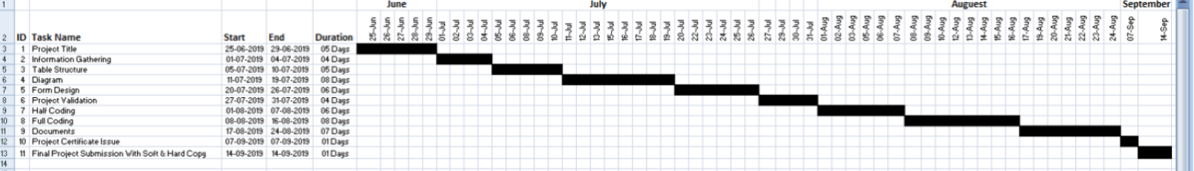

Chapter No: 3

System DESIGN

3.1 Data Flow Diagram

3.2 E-R Diagram

* 1. Use Case Diagram

3.1 DFD (Data Flow Diagram)

* DFD Level 0 (Context Level)



* DFD Level 1 (For Admin)
* DFD Level 1 (For Client)

3.2 ER Diagram (Entity Relationship)



3.3 ER Diagram (Entity Relationship)





Chapter No: 4

DATA DICTIONARY

4.1 Data Dictionary

4.2 Data Dictionary

**Table Name – “cpu”**

| **Field Name** | **Type/Size** | **Description** |
| --- | --- | --- |
| no | int/11 | Identification Number |
| series | varchar/20 | This contains the series name of the CPU (eg- Ryzen 5, Ryzen 7) |
| name | varchar/50 | Contains the name of the CPU (eg- 2700, 2700X) |
| cores_threads | varchar/10 | Contains the number of cores and threads of the CPU. |
| stock_freq | varchar/11 | Shows the stock speed of the CPU. |
| boost_freq | varchar/11 | Shows the boost speed of the CPU |
| transistor_size | varchar/11 | Sows the size of the transistor in nanometer (eg- 7nm) |
| total_cache | varchar/11 | Shows the total cache memory of the CPU |
| l1 | varchar/11 | Amount of Level 1 Cache |
| l2 | varchar/11 | Amount of Level 2 Cache |
| l3 | varchar/11 | Amount of Level 3 Cache |
| cooler | varchar/40 | Names the included cooler |
| TDP | varchar/11 | Show the Boost Clock TDP |
| prize | int/11 | Launch Prize |
| discount | int/11 | Discounts when needed |
| url | varchar/10000 | URL of the amazon.in search result |
| type | varchar/10 | Shows if the Product is a server grade or for gamers |
| img | varchar/10000 | This field contains the url of the image of the cpu |

**Description:-** This table is used to store the details of the CPUs.

**Table Name – “gpu”**

| **Field Name** | **Type/Size** | **Description** |
| --- | --- | --- |
| no | int/11 | Identification Number |
| series | varchar/50 | This contains the series name of the GPU (eg- Radeon, Navi) |
| name | varchar/50 | Contains the name of the GPU (eg- RX580, RX 560) |
| compute_units | varchar/11 | Contains the number of Compute Units |
| stream_processors | varchar/11 | Contains the number of Stream Processors |
| texture_units | varchat/11 | Contains the number of Texture Units |
| stock_freq | varchar/20 | Shows the stock speed of the GPU |
| boost_freq | varchar/20 | Shows the boost speed of the GPU |
| game_freq | varchar/20 | Show the Special Gaming Clock Speed |
| transistor_size | varchar/11 | Sows the size of the transistor in nanometer (eg- 7nm) |
| transistor_count | varchar/20 | Shows the number of Transistors |
| output | varchar/200 | Show the Output Ports of the GPU |
| memory_type | varchar/10 | Shows the Memory Type |
| VRAM | varchar/10 | Shows the amount of the Video RAM |
| prize | int/11 | Launch Prize |
| discount | int/11 | Discounts when needed |
| url | varchar/10000 | URL of the amazon.in search result |
| type | varchar/10 | Shows if the Product is a server grade or for gamers |
| img | varchar/10000 | This field contains the url of the image of the gpu |

**Description:-** This table is used to store the details of the GPUs.

**Table Name – “feedback”**

| **Field Name** | **Type/Size** | **Description** |
| --- | --- | --- |
| no | int/11 | Identification Number |
| name | varchar/100 | Name of the User |
| email | varchar/200 | Email of the User |
| phone | int/10 | Phone Number |
| date | varchar/100 | Date of time post |
| time | varchar/100 | Time of the post |
| ip | varchar/200 | IP of the User leaving the post |
| feedback | varchar/10000 | Feedback of the User |

**Description:-** This table is used to store the feedbacks.

**Table Name – “index_page_visits”**

| **Field Name** | **Type/Size** | **Description** |
| --- | --- | --- |
| sr | int/11 | Identification Number |
| ip | varchar/255 | IP of the visitor |
| time | varchar/100 | Time of the visit |
| date | varchar/100 | Date of the visit |

**Description:-** This table is used to store the IP address, date and time of the clients visiting the index.php page.

**Table Name – “login”**

| **Field Name** | **Type/Size** | **Description** |
| --- | --- | --- |
| no | int/11 | Identification Number |
| first_name | varchar/100 | First Name |
| last_name | varchar/100 | Last Name |
| username | varchar/30 | Username |
| password | varchar/30 | Password |
| admin | tinyint/1 | To check if the user is admin or not |
| mobile_number | varchar/100 | Mobile Number |
| email | varchar/255 | Email |
| dob | varchar/100 | Date of Birth |

**Description:-** This table is used to store the details of Users.

**Table Name – “news”**

| **Field Name** | **Type/Size** | **Description** |
| --- | --- | --- |
| id | int/11 | Identification Number |
| name | varchar/20 | Name of the User who posted |
| about | varchar/100 | About what the news is |
| content | varchar/10000 | The actual news |
| date | varchar/100 | Date of the Post |
| time | varchar/50 | Time of the Post |
| ip | varchar/255 | IP of the User who posted |

**Description:-** This table is used to store the posts of the admin.

Chapter No: 5

Input and output design

5.1 Admin Layout

5.2 Client Layout

5.1 Admin Layout

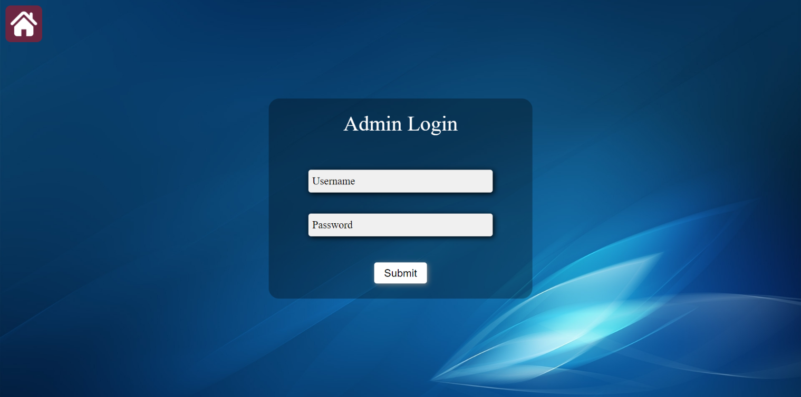1. Admin Login

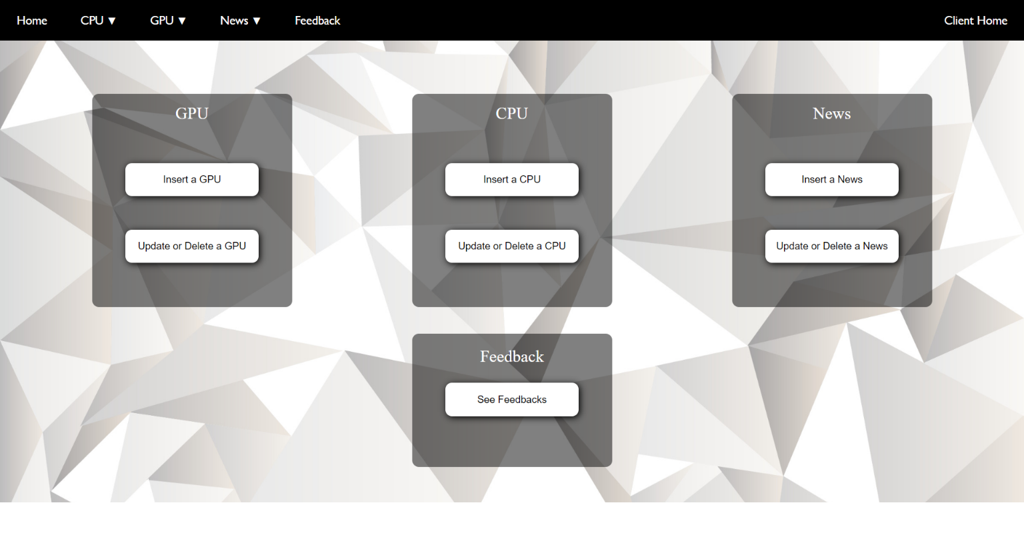2. Admin Index Page

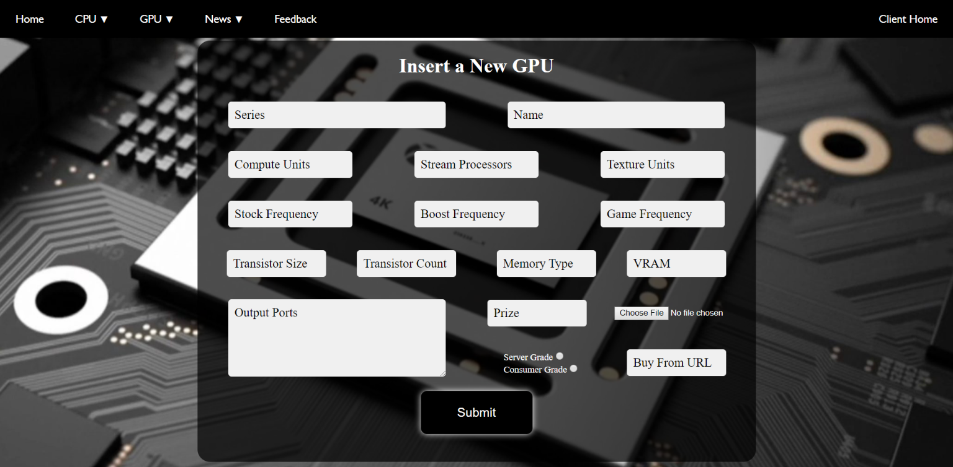3. GPU Insert

4. Update/Delete a GPU

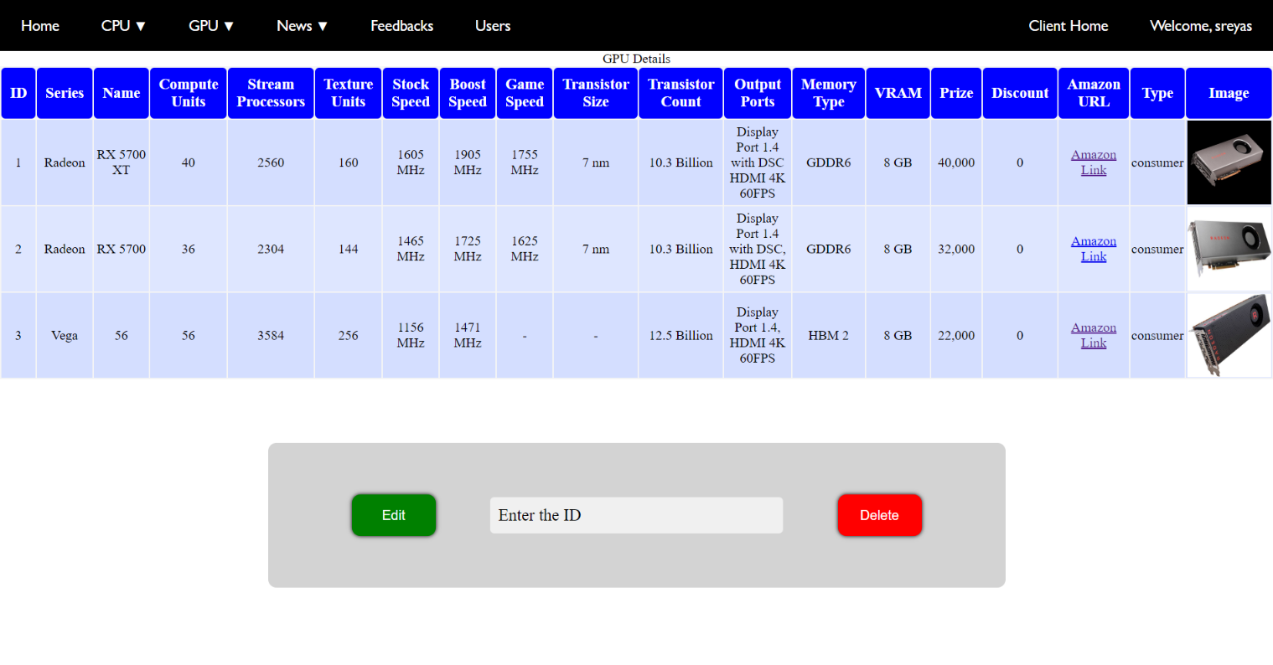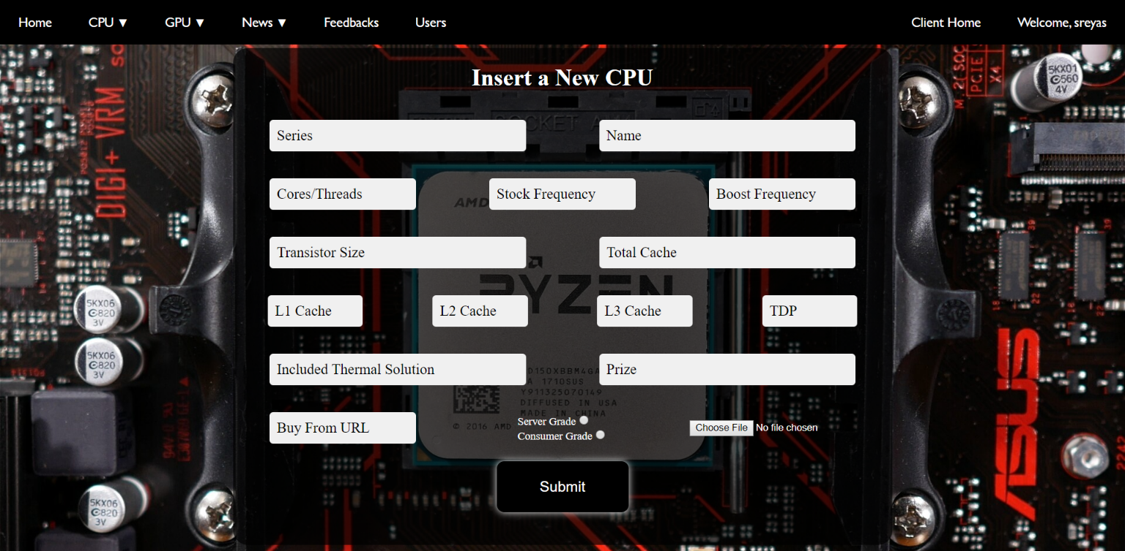5. CPU Insert

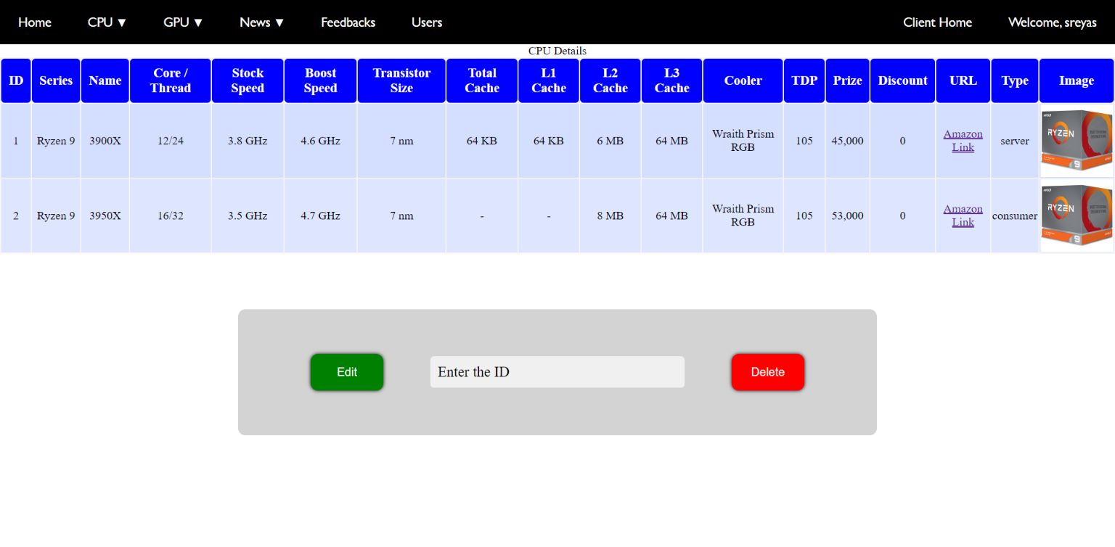6. Update/Delete a CPU

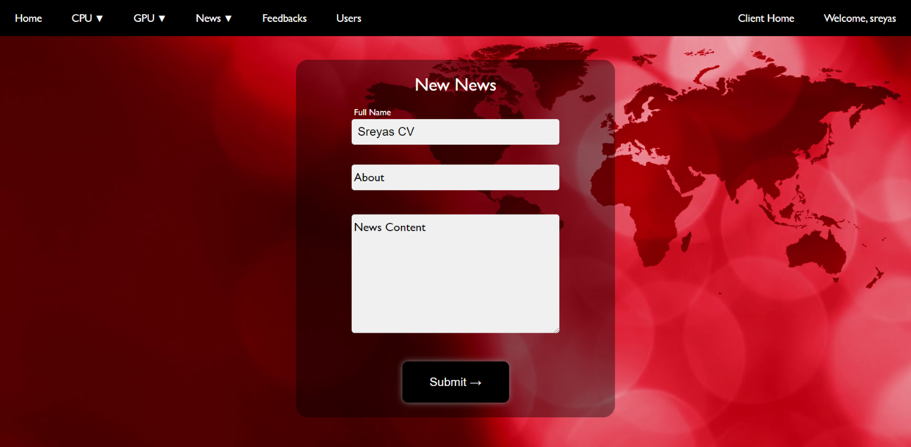7. News Insert

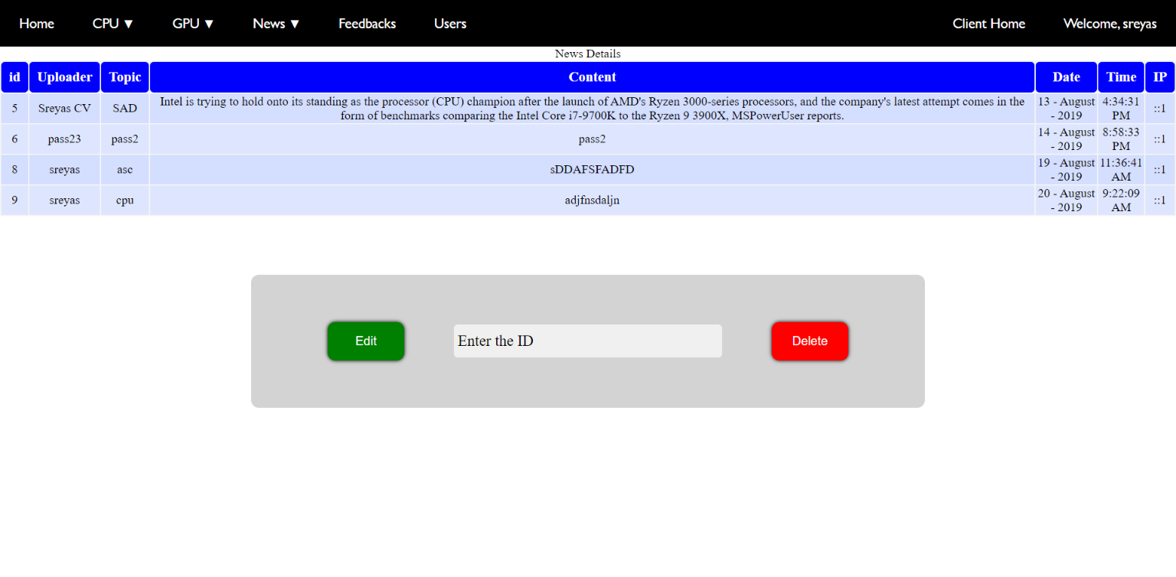8. Update/Delete News

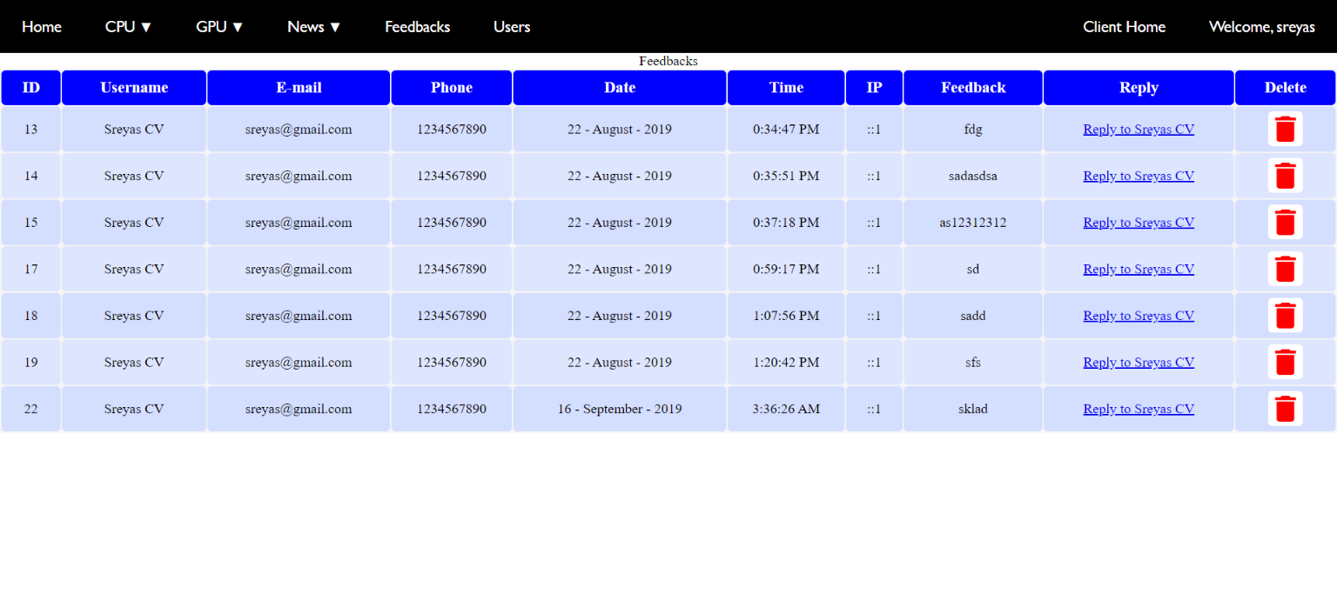9. View/Delete Feedbacks

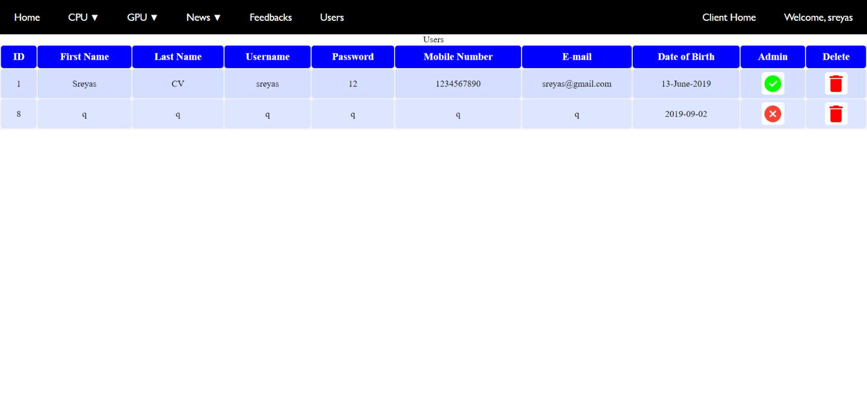10. Manage Users

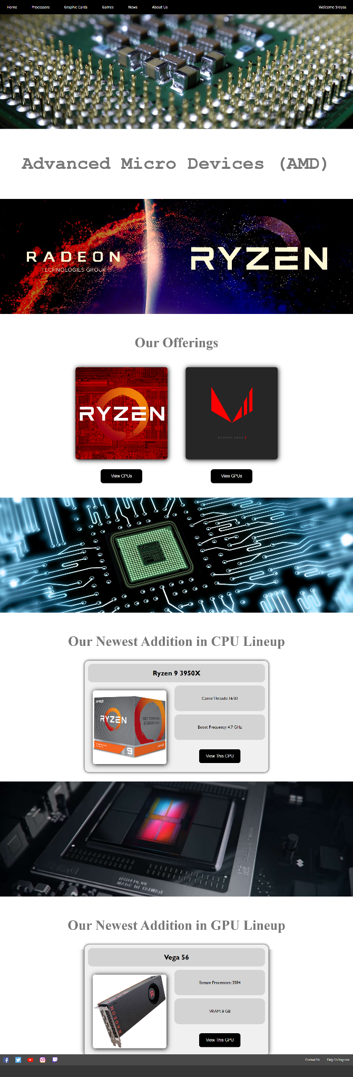5.2 Client Layout

1. Home Page

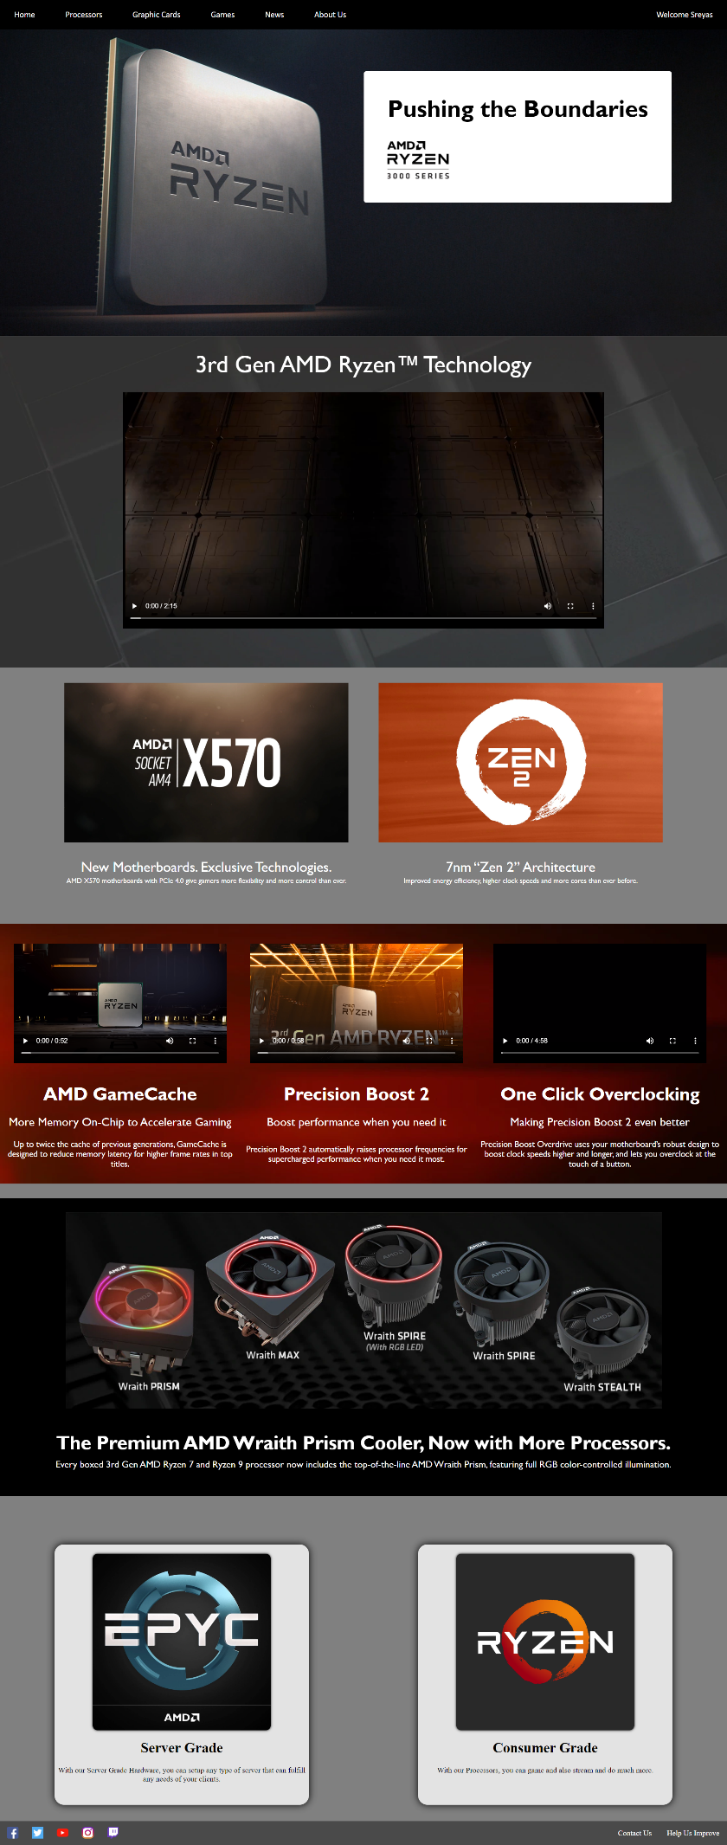2. Processors Page

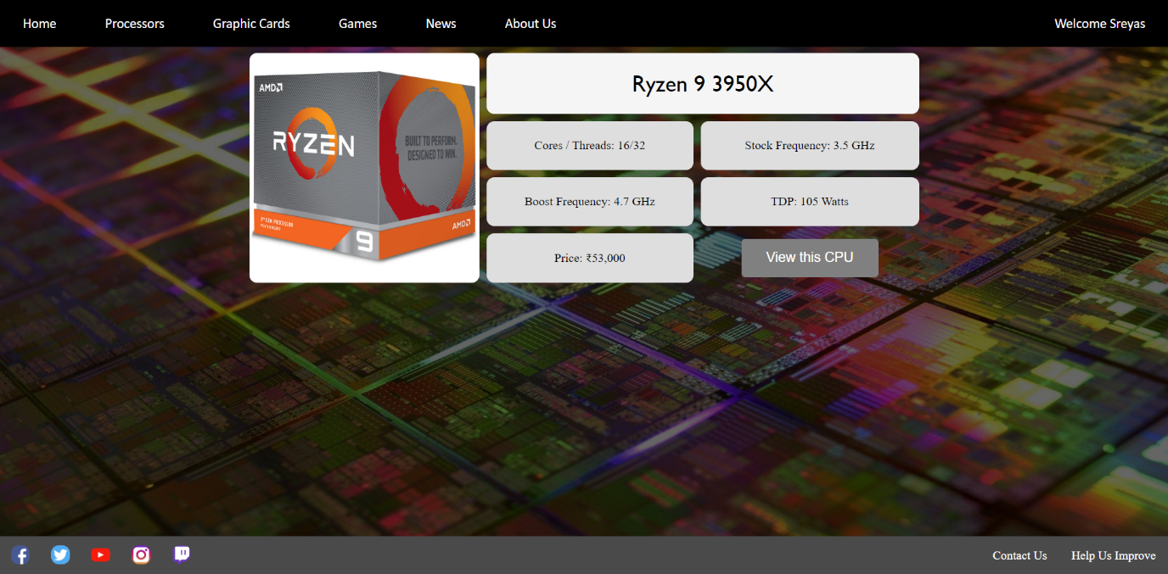3. Consumer/Server Grade CPU Page

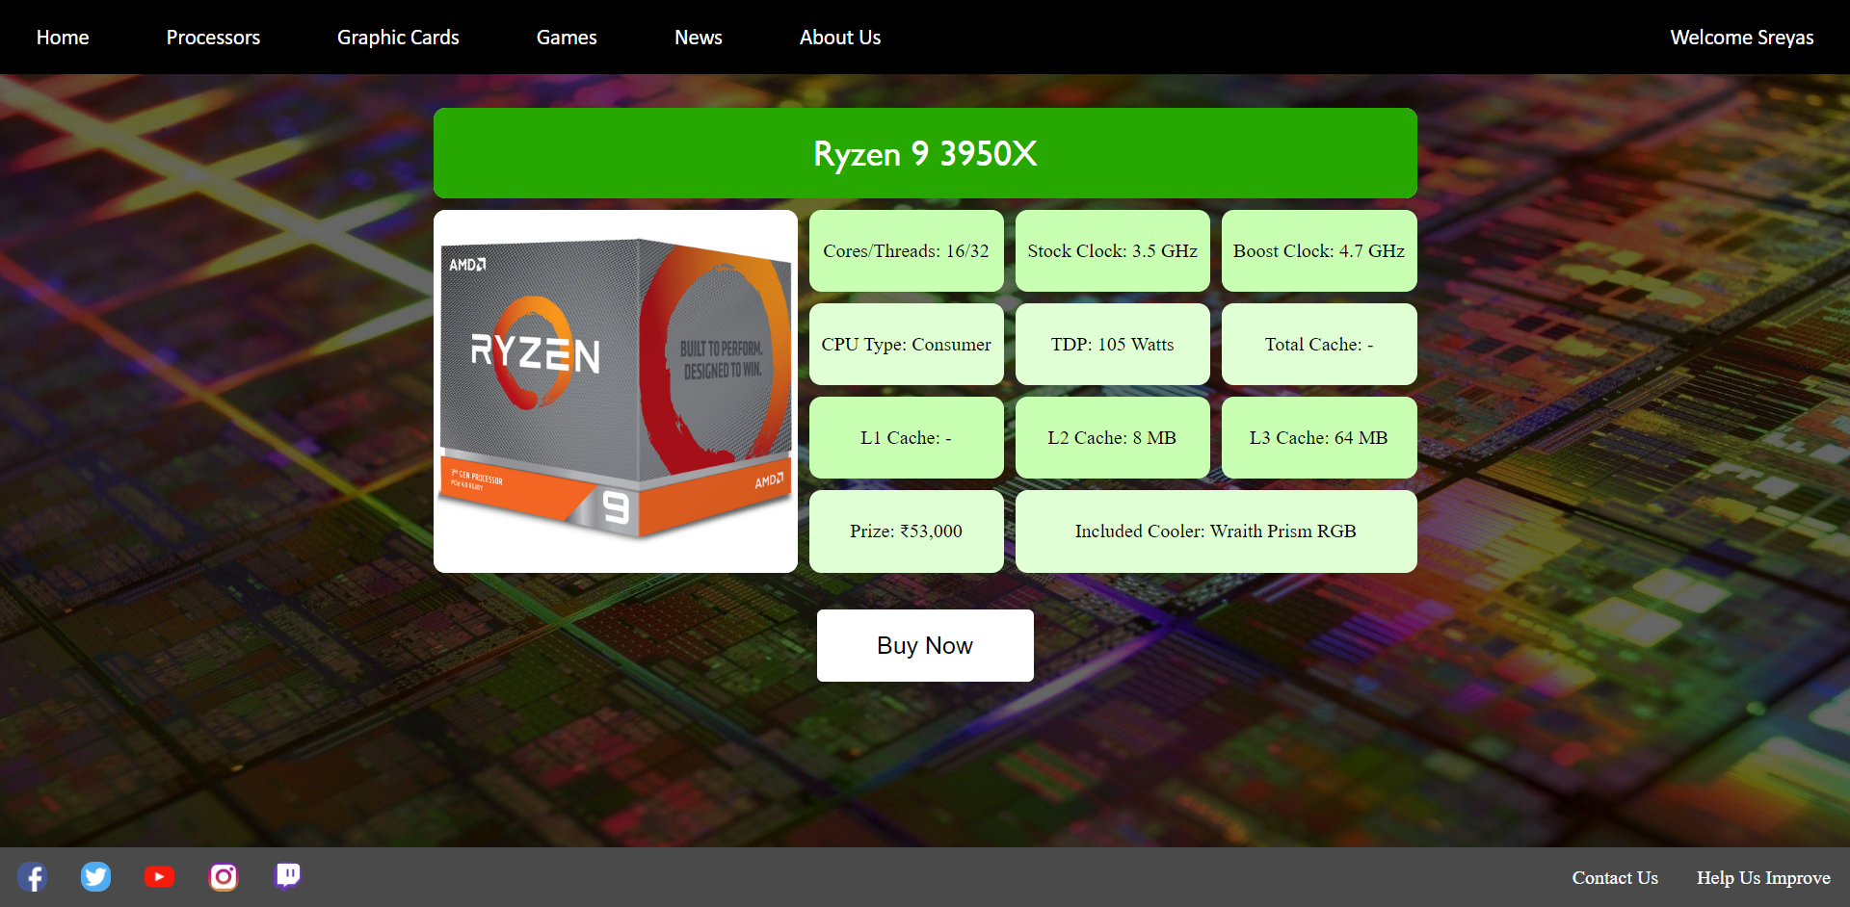4. Detailed CPU Display Page

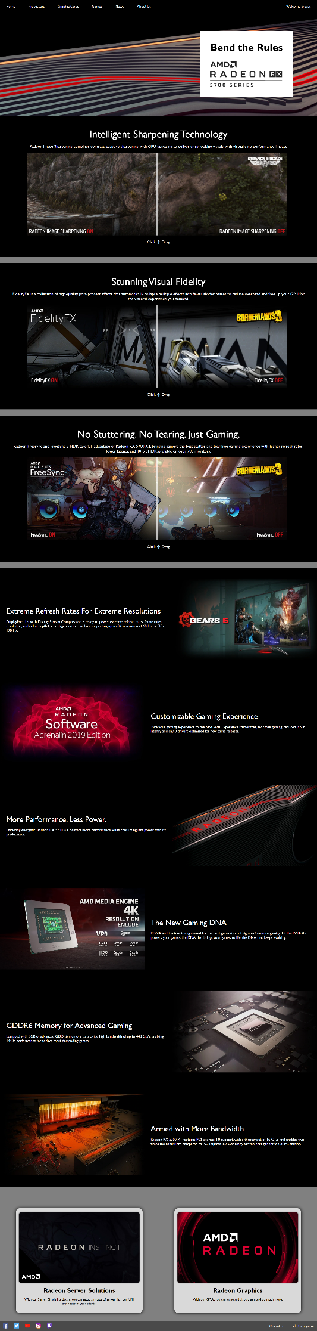5. Graphic Card Page

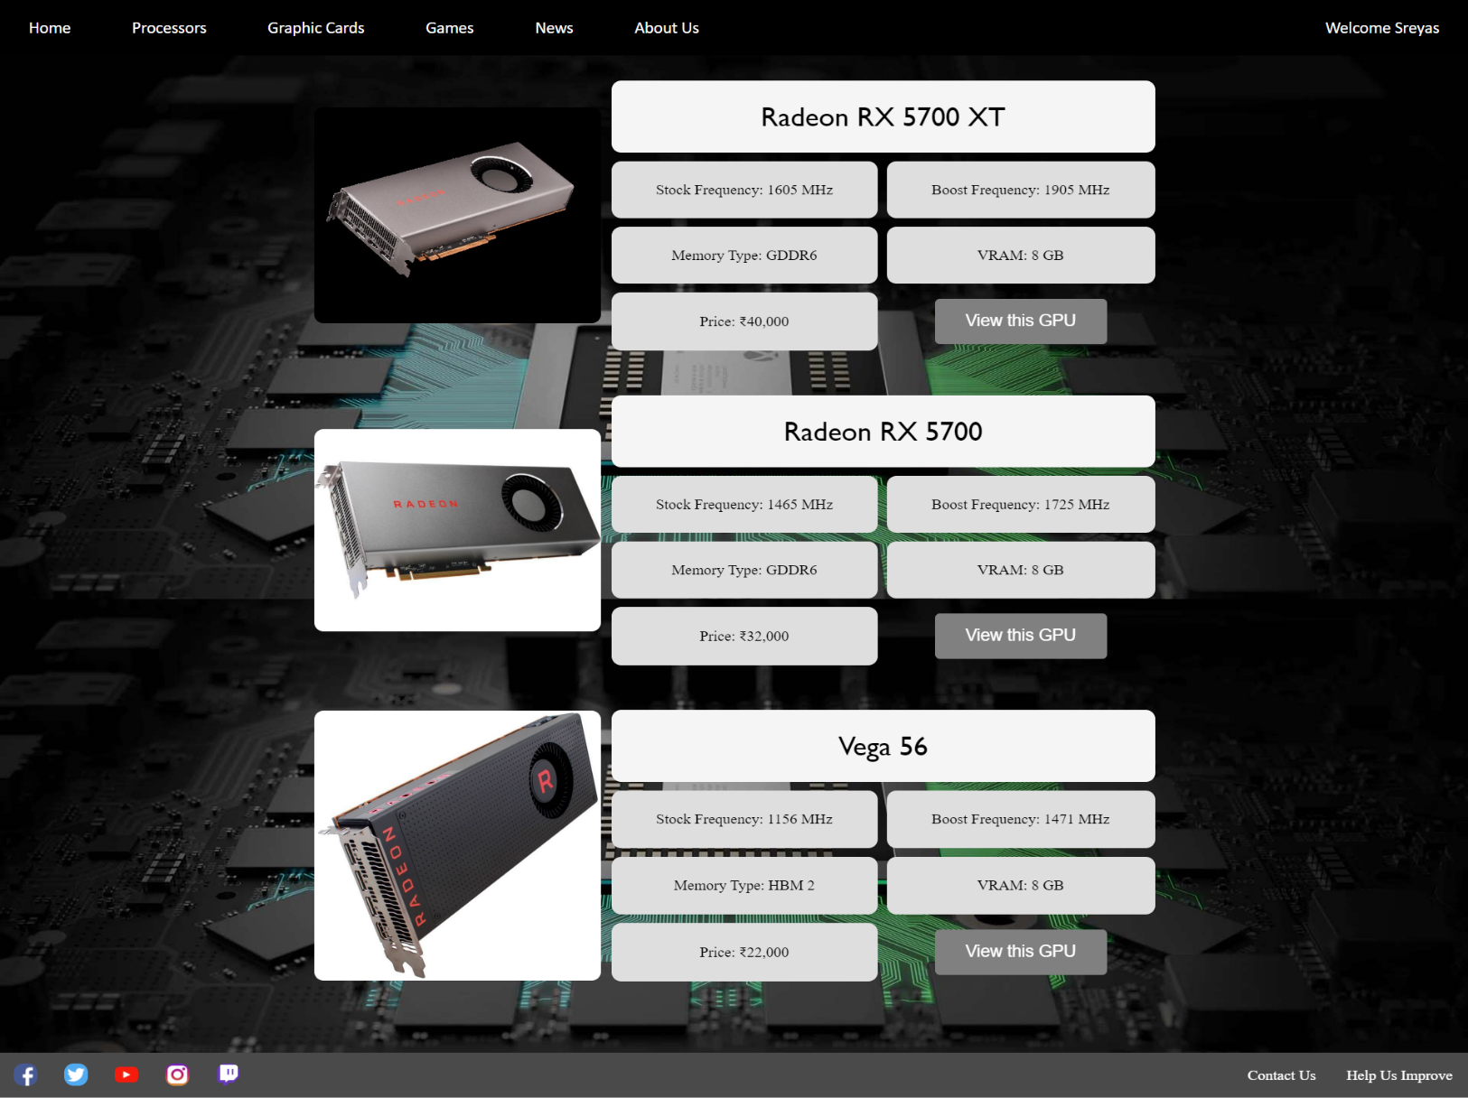6. Consumer/Server Grade GPU Page

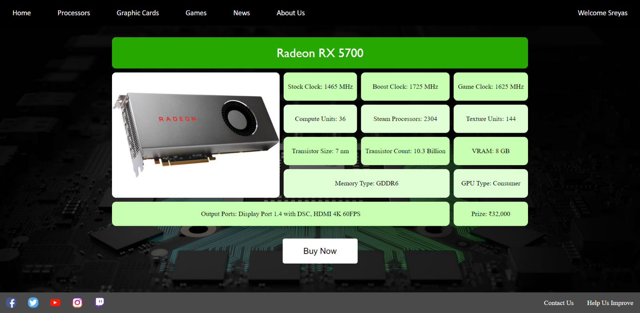7. Detailed CPU Display Page

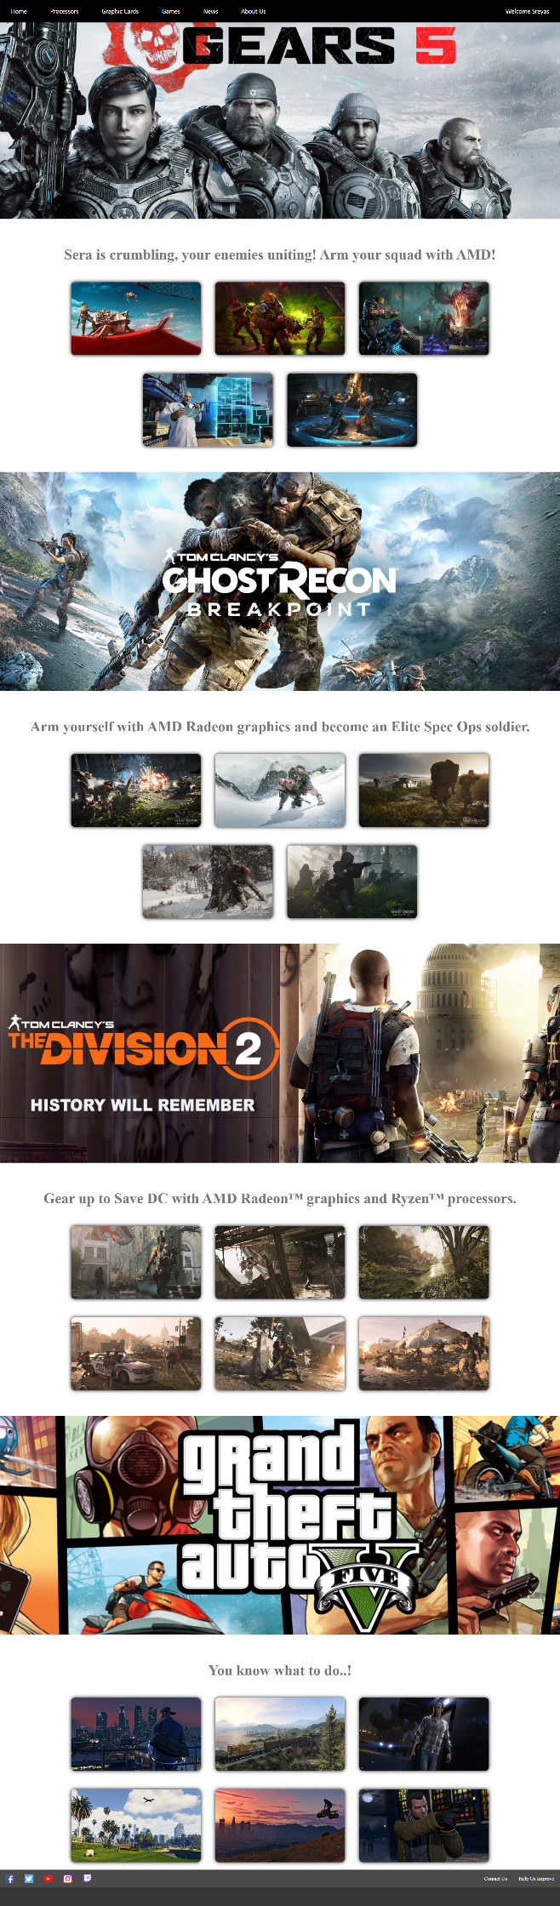8. Games Page

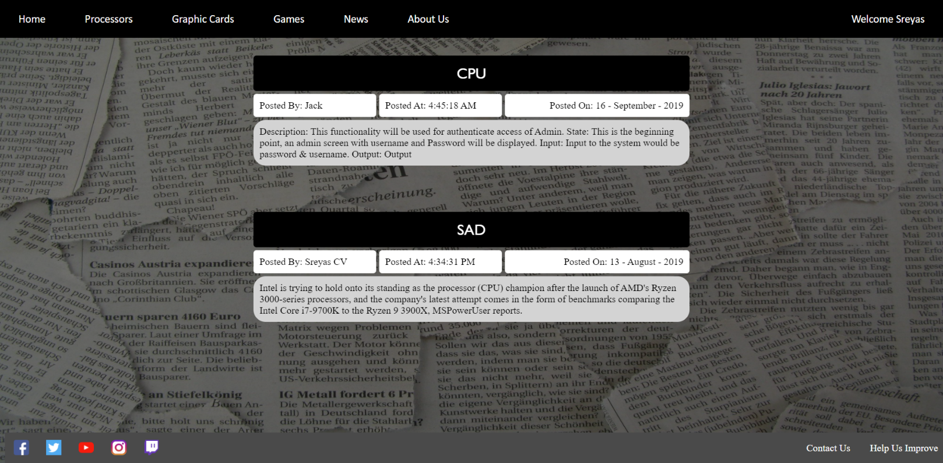9. News Page

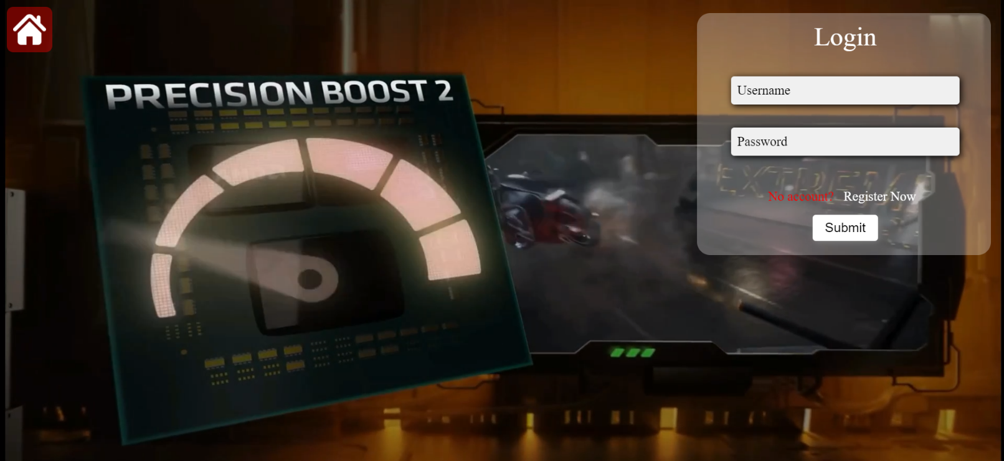10. Login Page

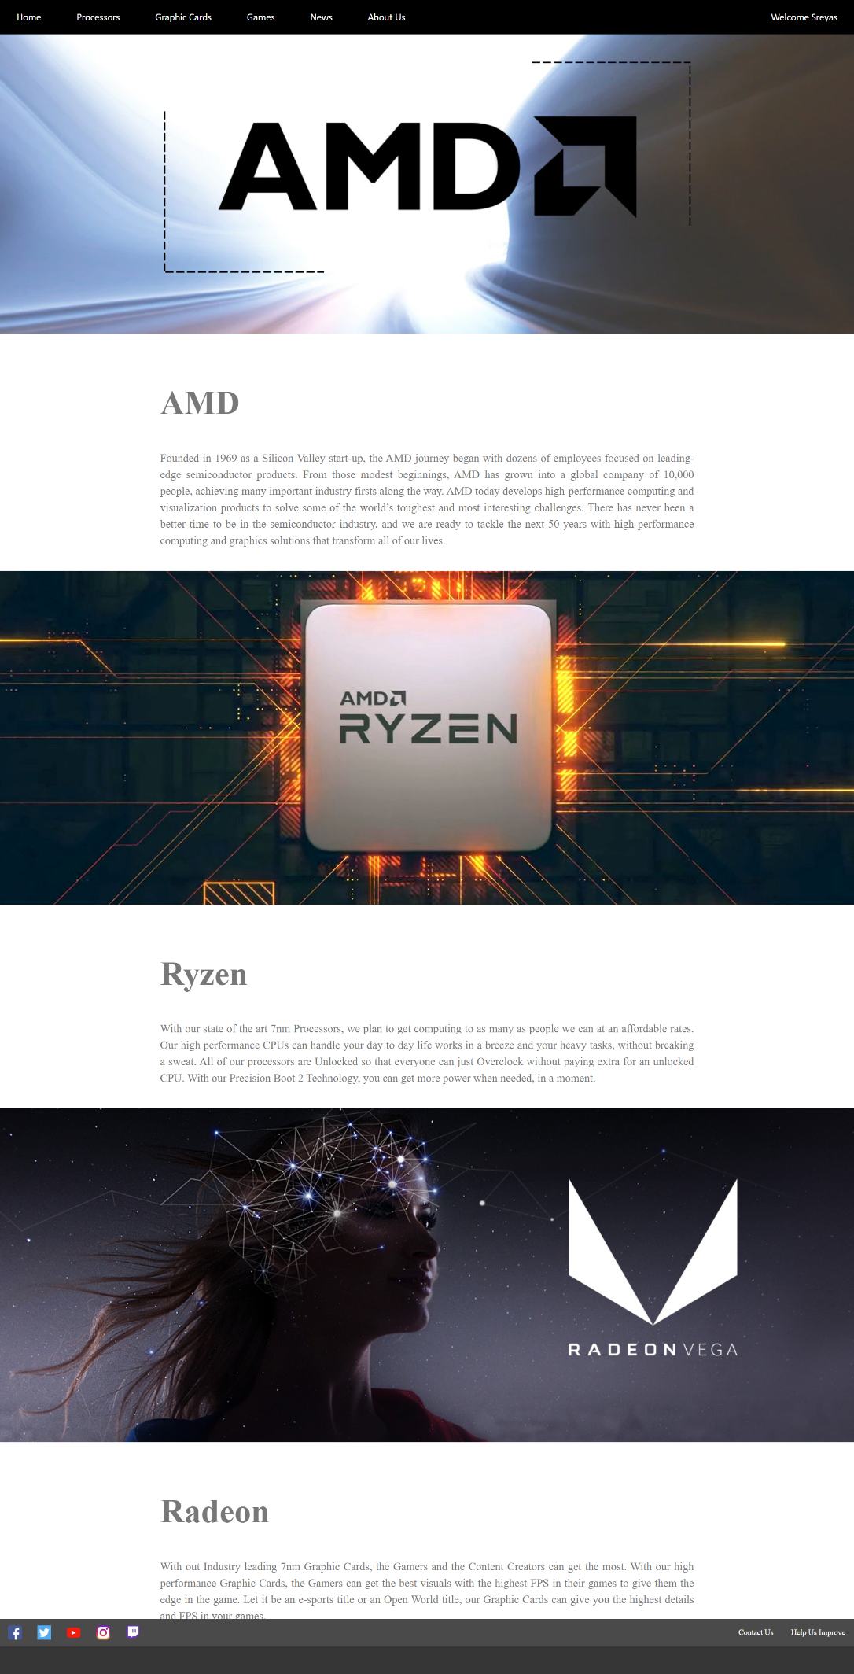11. About Us

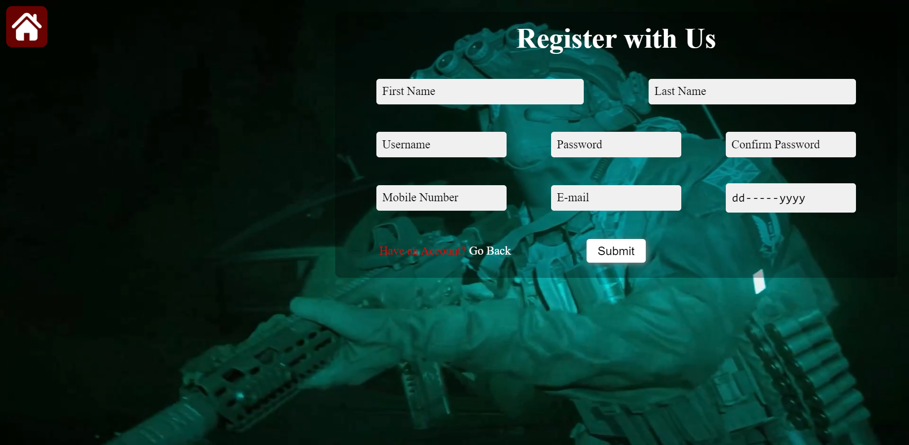12. Register Page

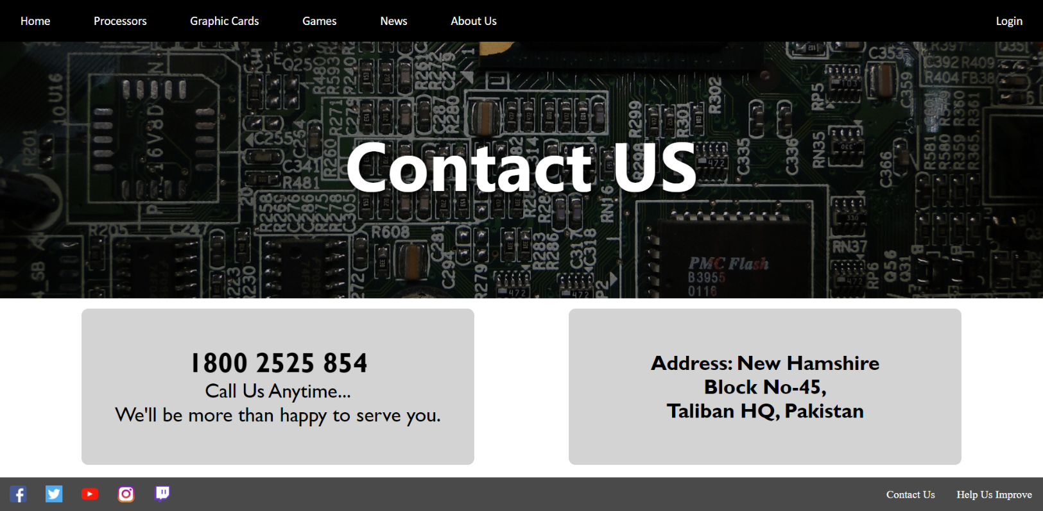13. Contact Us Page

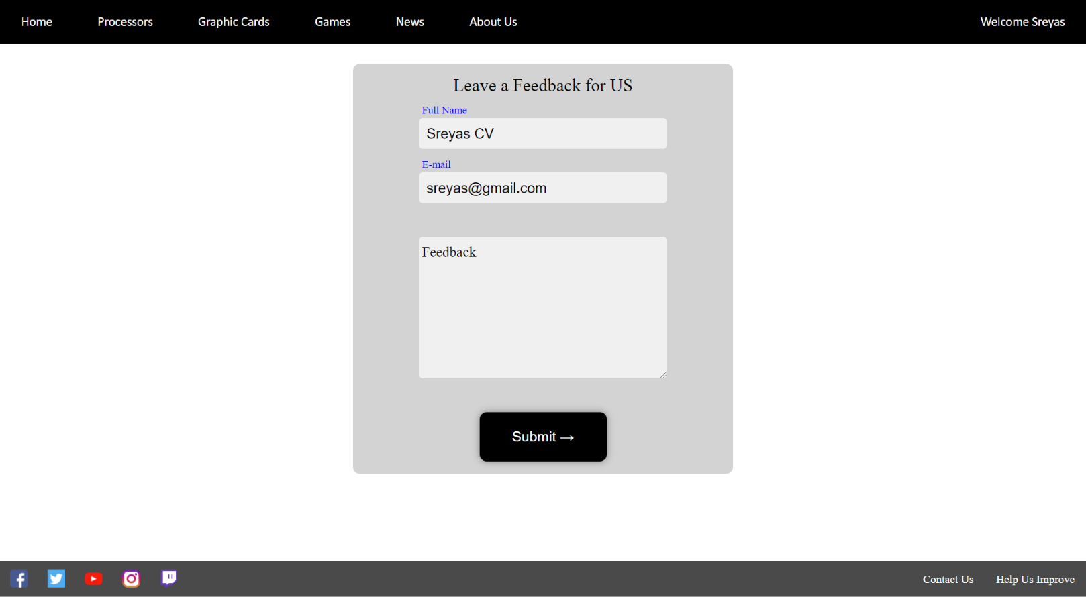14. Feedback Page

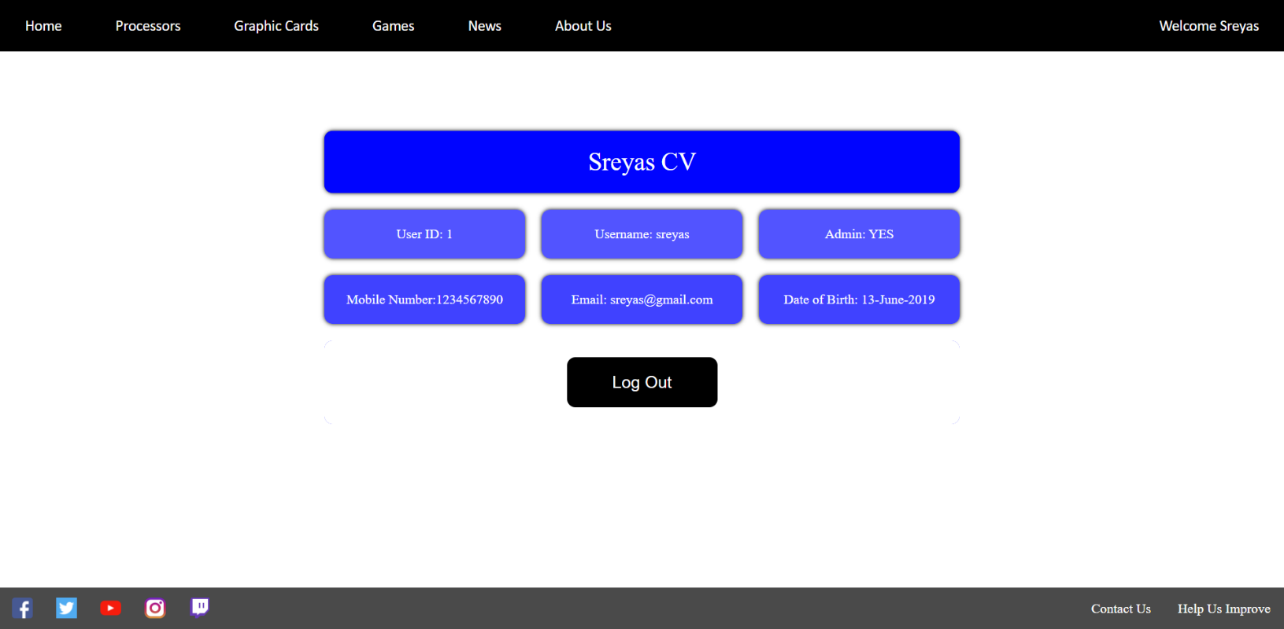15. Account Details Page

Chapter No: 6

limitations and future enhancements

6.1 Limitations

6.2 Future Enhancements

6.1 Limitations

* No backup features.
* No Individual end pages for product category.
* Can’t directly sell the products.
* Not tracking users like Google and Facebook does.
* No User specific functionalities.
* No ads in the website
* No email newsletters.

6.2 Future Enhancements

* Incorporate a redundant server for the data
* Include a different product display page for different generation of the products
* Sell the products here on the website
* Incorporate email newsletters

Chapter No: 7

conclusion

7.1 Advantages

7.2 Conclusion

7.1 Advantages

* User Friendly UI
* Easy Navigation
* Lists all products
* A way of advertisement
* Convenient for a user to view the website on their device
* Fast response of the server due to less complications in the software

7.2 Conclusion

This website is a perfect package for a semiconductor based company. Using this website, the company can showcase their products to the masses and attain more attention and potentially attract more customers. This website is convenient for the users to stay at the home or look up things on the go without visiting stores and waste time on travelling.

Chapter No: 8

BIBLIOGRAPHY

8 Bibliography

**PHP** – for server side scripting

**JavaScript** – for client side scripting

**jQuery** – as an alternate for JavaScript

**CSS** – to style the website

Chapter No: 9

References

References

We are really thankful to our guider Mr. Zalak Thakrar to guide us and inspire us. We also Thankful to the whole staff of computer Department to gives us a huge support in our project.

**Sites:**

[www.stackoverflow.com](http://www.stackoverflow.com)

[www.codepen.io](http://www.codepen.io)

[www.w3schools.com](http://www.w3schools.com)

[www.github.com](http://www.github.com)

[www.wikipedia.com](http://www.wikipedia.com)